Jon Janelle

MAT 500

10/1/13

**Chapter 6 Exercises**

**6.2A)**

Let $θ$ be the probability of flipping a heads. I chose the prior probability density $p\left(θ\right)=\frac{1}{3}β\left(2,18\right)+\frac{1}{3}β\left(40, 40\right)+\frac{1}{3}β(18,2)$ to express the approximately equal beliefs that the coin might be fair, biased toward heads, or biased toward tails. This distribution was chosen because it shows three distinct peaks. The peak near 0 expresses a belief that the coin may be biased toward tails, the peak at 0.5 the belief that the coin is fair, and the peak near 1.0 the belief that the coin is biased toward heads. This prior density was discretized using a step size of $∆θ=0.001$, and the resulting prior probability mass function is shown in the plot below.

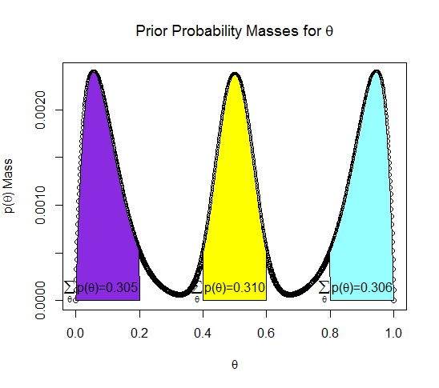

On the plot, the total probability masses for $p(0<θ<0.2)$, $p(0.4<θ<0.6)$, and $p(0.8<θ<1.0)$ are shown as approximations of the strength of the beliefs that the coin is tails biased, fair, and heads biased, respectively. The closeness of these probability masses expresses our approximately equal prior beliefs in each of the three options, which provides further evidence for the appropriateness of this prior.

**(B)**

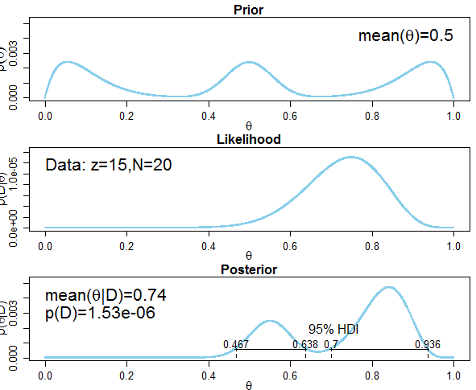

The posterior beliefs about $θ$ given that a sample of 15 heads and 5 tails were observed are shown in the plot above. Based on this plot, it is credible to believe that the coin is either fair or biased towards heads, but the possibility of a strong tails bias, $θ<0.3$, is no longer credible as these values are outside of the 95% HDI.

**6.3A)** The following graph shows the posterior distribution, $p\left(θ | D\right)$, after the prior distribution from problem 6.2 is updated with data from a sample 3 heads and 1 tail.

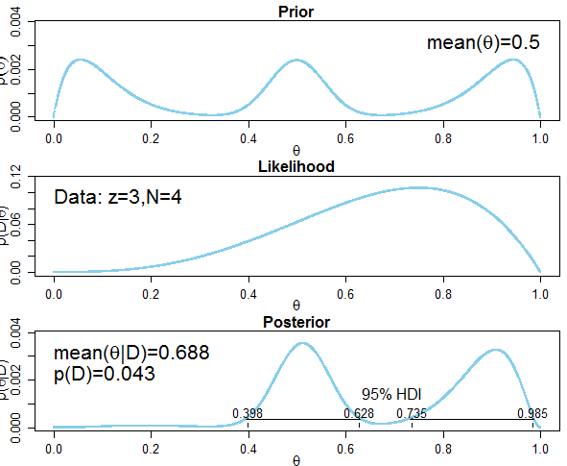

As in exercise 6.2, the posterior distribution is pulled toward larger values of $θ$ by a sample in which 75% of the flips were heads. However, the small sample of 4 predictably did not affect the posterior as strongly at the larger sample size used in exercise 6.2, which is shown by the smaller values of $θ$ that are included in the 95% HDI.

**(B)** The posterior distribution found in 6.2A is used as the

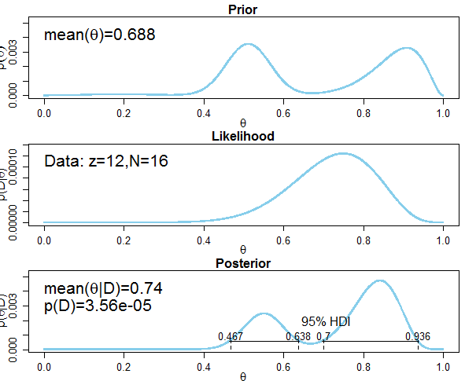

After updating the posterior with a second sample of 12 heads and 4 tails, bringing the combination between the two samples to 15 heads and 5 tails, the posterior distribution now matches the one obtained in exercise 6.2 when a single sample of 15 heads and 5 tails was used. This demonstrates that the order in samples are collected does not affect the posterior distribution.

**6.4A)**

The prior distribution for $θ$, the proportion of voters favoring candidate A, is a discretized uniform distribution on [0,1] with $∆θ=0.001$. This prior expresses the belief that voters are equally likely to prefer candidate A as they are candidate B. The plot below shows the posterior distribution obtained given data from a poll of 100 people in which 58 preferred candidate A.

The 95% HDI is $0.483≤θ≤0.673$. Given that $θ=0.5$ lies within the HDI, we cannot conclude that voters show a greater preference for candidate A than candidate B.

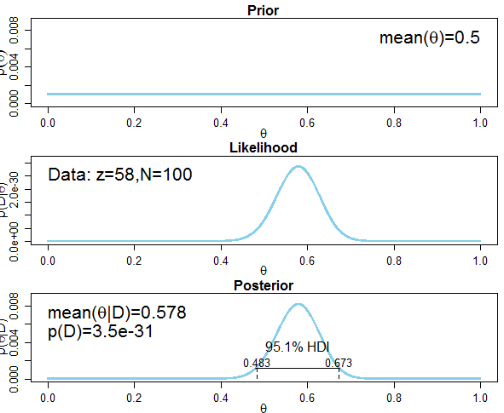

**(B)**

Since $θ=0.5$ lies within the 95% HDI, it is credible to conclude that voters are equally divided in their preferences among candidates. However, in the posterior distribution $\sum_{θ>0.5}{p(θ|D)}=0.943$, so it is more likely that the true value for $θ$ indicates a preference for candidate A.

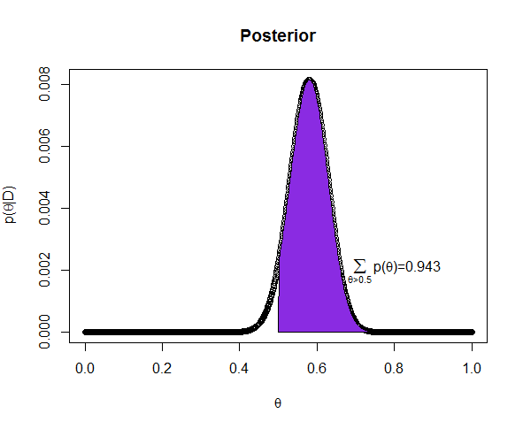

**(C & D)**

The plot below shows the posterior distribution obtained given data from a second poll of 100 people in which 57 preferred candidate A. The posterior obtained after the first poll is used as the prior distribution.

The 95% HDI is $0.507≤θ≤0.642$. Since $θ=0.5$ lies outside of the HDI, $θ=0.5$ is not a credible value and we conclude that voters show a greater preference for candidate A than candidate B.

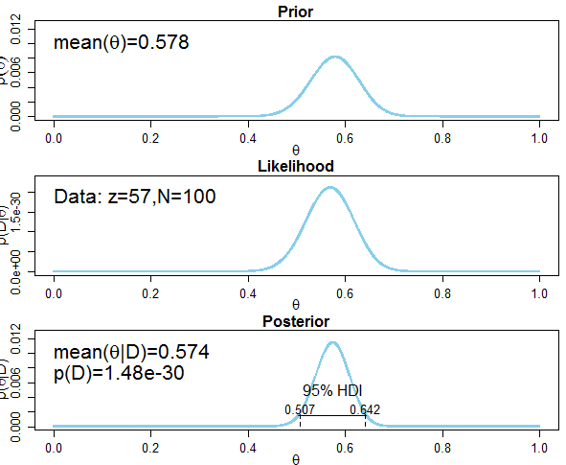

**6.7.**

The plots below show the head biased prior $p\left(θ | M1\right)∝θ^{2}$, and the tail-biased prior $p\left(θ | M2\right)∝{(1-θ)}^{2}$.

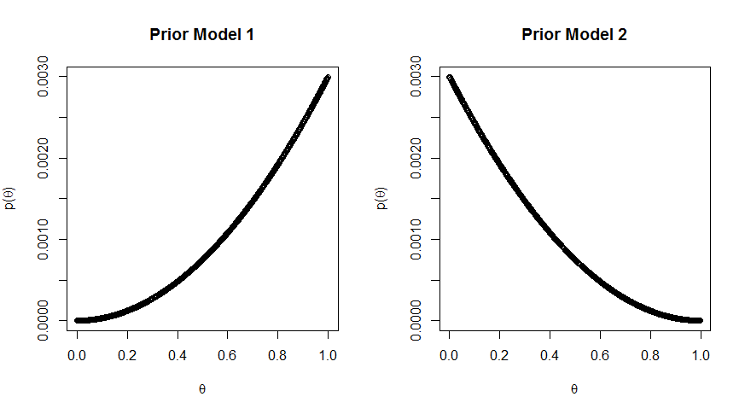

The plots below show the posterior distributions for each model after a sample of 6 heads and 2 tails. The Bayes factor is $\frac{p\left(D | M1\right)}{p(D|M2)}=\frac{0.00606}{0.0013}=4.662,$ which indicates that model 1 is superior to model 2.

***Model 1 Posterior***

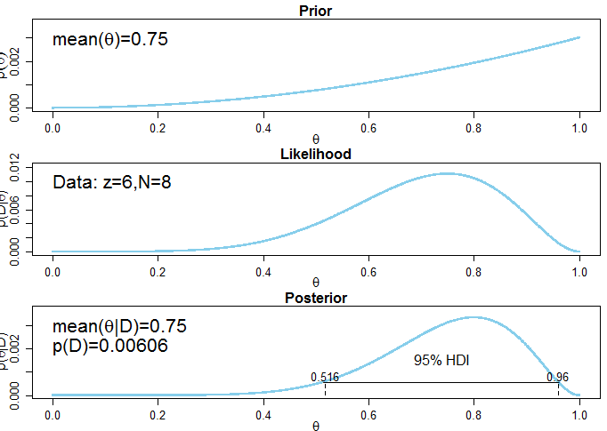

***Model 2 Posterior***

